EXNO: 9PERFORMANCE EVALUATION OF AM GENERATION AND DETECTION UNDER NOISY CHANNEL CONDITIONS USINGMATLAB

NAME:V.RUSHMITHA
DATE:08/10/2026
Objectives:
i) To generate an Amplitude Modulated (AM) signal, introduce Additive White Gaussian Noise
(AWGN), and analyze the effect of noise on the transmitted signal using MATLAB.
ii) To recover the original message signal from the noisy AM signal using envelope detection
and compare the transmitted and recovered waveforms to evaluate the performance of the AM
communication system.
Procedure:
1. Open MATLAB and create a new script file.
2. Define the simulation parameters, including the sampling frequency, time vector, message
frequency, carrier frequency, message amplitude, carrier amplitude, and Signal-to-Noise Ratio
(SNR).
3. Generate the message signal using a low-frequency sinusoidal waveform.
4. Generate the carrier signal using a high-frequency sinusoidal waveform.
5. Generate the Amplitude Modulated (AM) signal by modulating the carrier signal with the
message signal.
6. Introduce Additive White Gaussian Noise (AWGN) to the AM signal using the MATLAB
awgn() function with the specified SNR.
7. Perform envelope detection on the noisy AM signal using the Hilbert transform to recover
the original message signal.
8. Plot the message signal, carrier signal, AM signal, noisy AM signal, and recovered signal
using MATLAB subplots.
9. Compare the original message signal with the recovered signal to observe the effect of
AWGN on signal quality.
10. Analyze the performance of the AM communication system by studying the degradation
caused by noise and the effectiveness of the envelope detector in recovering the message signal.
11. Verify the successful generation, transmission, and recovery of the AM signal under noisy
channel conditions.
PROGRAM (MATLAB CODE)
clc;
clear;
close all;
% Parameters fs = 100000;
t = 0:1/fs:0.02;
fm = 500;
fc = 5000;
% Message Signal
m = cos(2*pi*fm*t);
c = cos(2*pi*fc*t);
% AM Modulation
am = (1 + m).*cos(2*pi*fc*t);
% Add AWGN Noise
noisy = awgn(am,10,'measured'); % 10 dB SNR
% Envelope Detection
env = abs(hilbert(noisy));
% Display Results
figure;
subplot(5,1,1)
plot(t,m)
title('Message Signal')
grid on
subplot(5,1,2)
plot(t,c)
title('Carrier Signal')
grid on
subplot(5,1,3)
plot(t,am)
title('AM Signal')
grid on
subplot(5,1,4)
plot(t,noisy)
title('AM Signal with AWGN Noise')
grid on
subplot(5,1,5)
plot(t,env)
title('Recovered Signal')
grid on
OUTPUT (GRAPH)
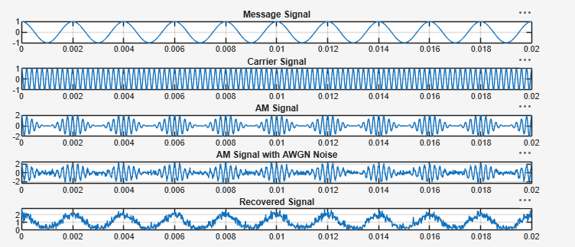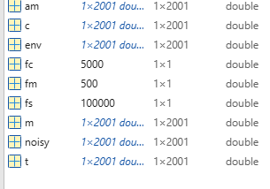
RESULTS
i) The AM signal was successfully generated in MATLAB, and the effect of Additive White
Gaussian Noise (AWGN) on the transmitted signal was observed through the noisy AM
waveform.
ii) The original message signal was successfully recovered using envelope detection,
demonstrating the effectiveness of the AM receiver in recovering the transmitted information.

